HOW TO CREATE ACCOUNT AND SUBMIT DOSSIER
- Type the following link on any browser of your choice (Chrome, Mozilla, Microsoft Edge)
https://nafdacdossier.ng/

2. Click on Sign in, then click on Don’t have an account

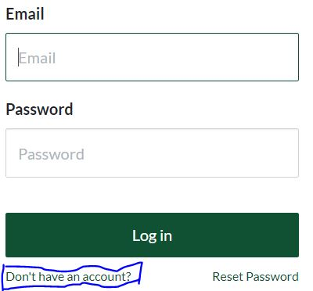

3. Enter your First Name, Email, and Password, then click on Sign Up Button

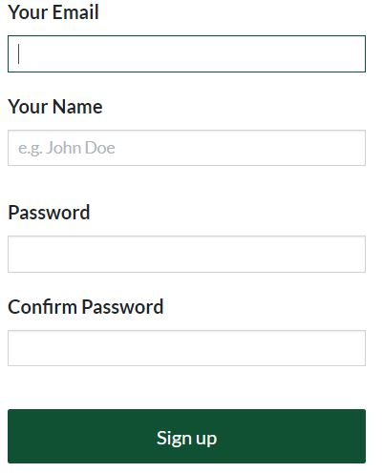

4. Check Your email inbox (or spam), then click the link in the email you received from NAFDAC Dossier Platform to verify your email.

5. Fill in your company and representative details and submit

6. Wait for approval from NAFDAC Team before you proceed to submit your dossier

